# General instruction for preparing the scenario files

1. Scenario files were used for making it easier to run scenario simulations.
2. The choice of which scenario file to read is specified in the globalParameters.rgg.
3. Within the scenario file one can specify the simulation settings, number of rows and plants in a row, pruning system, initial structural and nonstructural carbon concentration, leaf nitrogen concentration, climatic file, organ size file and leaf declination angle file. In addition, one can also input the berry size dynamics for model calibration.

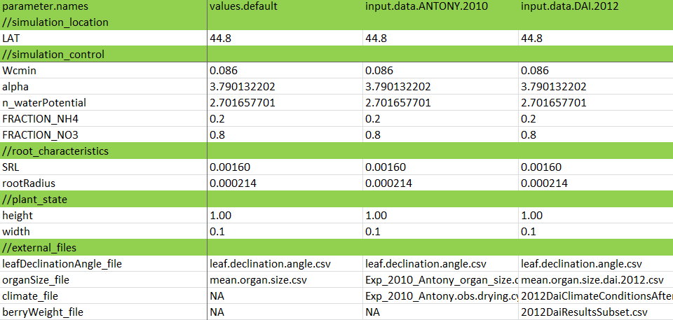

1. Different scenarios were first listed in the excel file of ‘model input data list.xlsx’. one column represent one scenario.
2. The model scenario files can be created by the R script: ‘model scenario creation.r’, located in the Model_scenarios\Model scenario file creation\. The R script read the ‘model input data list.xlsx’, and creates the corresponding txt file. The names of file as well as initial conditions for the model are defined in this excel file. The first line defines the name of this scenario, while the names below define the initial conditions and files for read.
3. Similarly plant parameters are stored in \Model_scenarios\model plant parameter list git\. The parameter file can also be created by the R script: ‘model scenario creation.r’.